Java fx is media/graphic framework for creating GUIs in Java Applications
its replce the swing -java fx came in may 2007. to make UI qualitative , attractive Java Fx is very is very useful
java fx can be integrated in swing application, allowing for smoother transaction.
Jframe , swing window,
replcasement of swing
helow world window using java fx/ swing
in java fx it is very easy to integrate of sound, images and videos of web content
java fx terminology is little bit different from swing
how to use java Fx in eclips
step 1 : add java fx jar files
step 2 : careate a project name s with javafx folder
create a class name it as chello world
add the java Fx jars
creates a basic GUI application with a single button and a label.
import javafx.application.Application;
import javafx.scene.Scene;
import javafx.scene.control.Button;
import javafx.scene.control.Label;
import javafx.scene.layout.VBox;
import javafx.stage.Stage;

public class firstProgram extends Application {

@Override
public void start(Stage primaryStage) {
// Create a label
Label label = new Label("Welcome to JavaFX!");

// Create a button
Button button = new Button("Click Me");

// Set an action for the button
button.setOnAction(e -> label.setText("Hello, JavaFX!"));

// Create a layout and add components
VBox layout = new VBox(10); // VBox with 10px spacing
layout.getChildren().addAll(label, button);

// Create a scene with the layout
Scene scene = new Scene(layout, 300, 200);

// Set up the stage
primaryStage.setTitle("JavaFX Example");
primaryStage.setScene(scene);
primaryStage.show();
}

public static void main(String[] args) {
launch(args); // Launch the JavaFX application
}
}
// java Fx plugin using
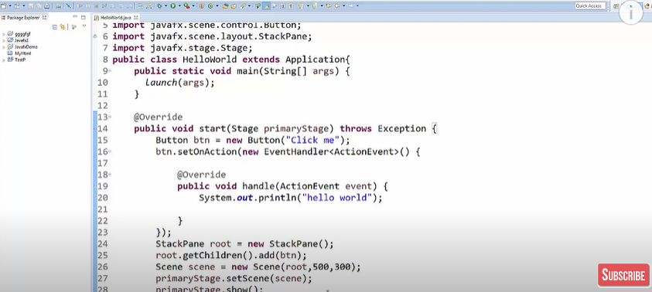
we can use lambda expression in btn.setOnAction()
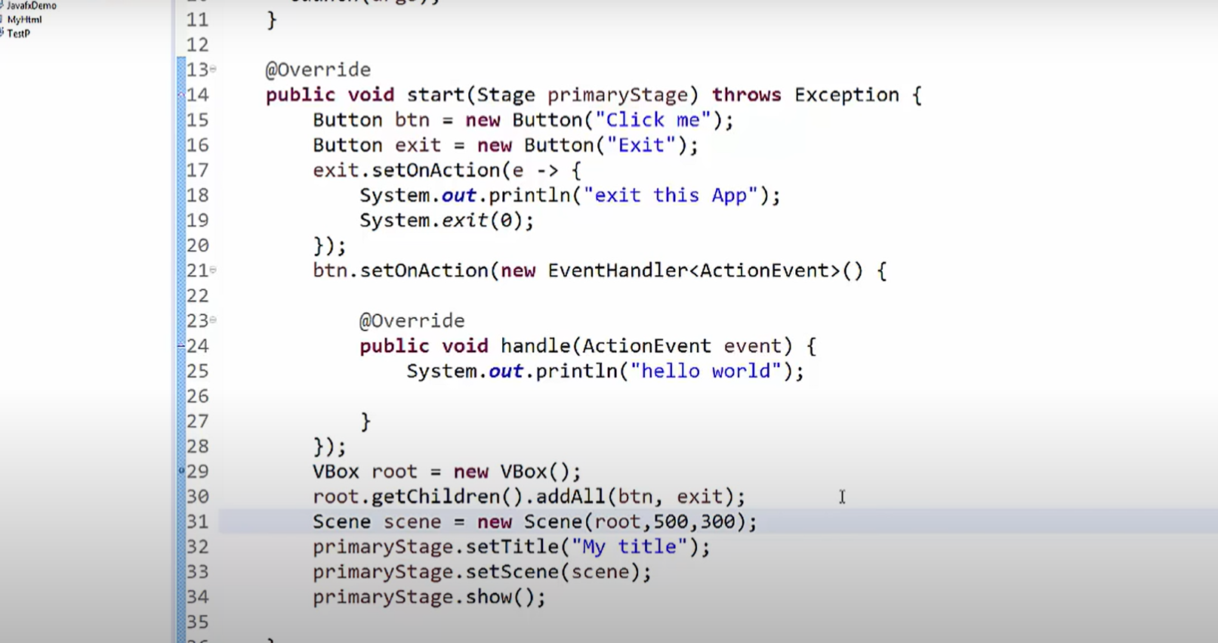
1. Stage
The Stage is the top-level container in a JavaFX application. It represents the window of your application.
The primaryStage is the main stage provided by the JavaFX runtime when the application starts.
You can think of it as the main window where your content will be displayed.
Key Characteristics:
primaryStage is passed as an argument to the start(Stage primaryStage) method.
You can set the title, size, and content of this stage.
It can host only one Scene at a time.
You can create additional stages (windows) if needed using the Stage class, but primaryStage is special because it's the default starting point.
Code Reference:
java
Copy code
public void start(Stage primaryStage) {
primaryStage.setTitle("JavaFX Example"); // Sets the title of the main window.
}
2. Scene
The Scene represents the content displayed inside a Stage.
It acts as a container for the GUI components like buttons, labels, layouts, etc.
The Scene is responsible for managing all nodes (elements) added to it.
Key Characteristics:
You can set a Scene to a Stage using primaryStage.setScene(scene).
A Scene is typically constructed with a root node, such as VBox, HBox, Pane, etc., which organizes the layout.
*********************************************************************************
Why Use Scene Builder?
User-Friendly: Easily design complex interfaces with a drag-and-drop interface.
Separation of Logic and UI: Keeps UI design (FXML) separate from application logic (Java code).
Efficient Workflow: Reduces development time by automating layout generation.
Easy Integration: Works seamlessly with Java IDEs like IntelliJ IDEA, Eclipse, and NetBeans.
Steps to Use Scene Builder
1. Install Scene Builder
Download Scene Builder from the official Gluon website: https://gluonhq.com/products/scene-builder/
Install it on your system.
2. Create a JavaFX Project
Create a new JavaFX project in your preferred IDE (e.g., IntelliJ, Eclipse).
Include JavaFX libraries in your project.
3. Open Scene Builder
Open the .fxml file (created in your project) using Scene Builder.
Most IDEs allow you to right-click on the FXML file and select "Open in Scene Builder".
4. Design the User Interface
Drag components (e.g., Button, Label, TextField) from the library panel and drop them onto the design area.
Arrange the components in the desired layout.
Customize properties like size, text, color, alignment, etc., in the Properties panel.
5. Set Controller and Event Handlers
Assign an FXML Controller Class to the FXML file via the Controller section in Scene Builder.
Link UI elements to methods in the controller for handling events (e.g., button clicks).
6. Save the FXML File
Scene Builder generates an updated FXML file reflecting your design.
Save the changes.
FXML Example
Here’s an example of a simple interface created using Scene Builder:

FXML File (sample.fxml)
xml
Copy code
<?xml version="1.0" encoding="UTF-8"?>
<?import javafx.scene.control.*?>
<?import javafx.scene.layout.*?>

<VBox xmlns="http://javafx.com/javafx"
xmlns:fx="http://javafx.com/fxml"
fx:controller="com.example.Controller" spacing="10" alignment="CENTER">
<Label text="Welcome to JavaFX!"/>
<Button text="Click Me" onAction="#handleButtonClick"/>
</VBox>
Controller File (Controller.java)
java
Copy code
package com.example;

import javafx.fxml.FXML;
import javafx.scene.control.Label;

public class Controller {

@FXML
private Label label; // Linked to the Label in the FXML file

@FXML
public void handleButtonClick() {
label.setText("Hello from Scene Builder!");
}
}
Main Application File (Main.java)
java
Copy code
import javafx.application.Application;
import javafx.fxml.FXMLLoader;
import javafx.scene.Parent;
import javafx.scene.Scene;
import javafx.stage.Stage;

public class Main extends Application {

@Override
public void start(Stage primaryStage) throws Exception {
Parent root = FXMLLoader.load(getClass().getResource("sample.fxml"));
primaryStage.setTitle("Scene Builder Example");
primaryStage.setScene(new Scene(root, 300, 200));
primaryStage.show();
}

public static void main(String[] args) {
launch(args);
}
}
Integrating Scene Builder with IDEs
For IntelliJ IDEA
Go to File → Settings → Languages & Frameworks → JavaFX.
Set the path to the Scene Builder executable.
You can now right-click any .fxml file and open it in Scene Builder.
For Eclipse
Install the e(fx)clipse plugin.
Configure the external Scene Builder path under preferences.
Open .fxml files with Scene Builder.
For NetBeans
Scene Builder comes pre-integrated with older versions of NetBeans.
In newer versions, manually set the Scene Builder path.
Advantages of Scene Builder
Intuitive drag-and-drop design.
Fewer syntax errors in FXML.
Visualization of UI before running the application.
Better collaboration between designers and developers.
Let me know if you’d like help setting up Scene Builder or exploring advanced JavaFX features!
*********************************************************************************

